**Purpose:**

My website is about a new game to be released soon. It gives a brief description of the game content and attracts more people to play.

**Target Audience:**

This game is a remake of an old game, for those who have deep feelings for the game, and young people who love playing the game.

**Visual Appeal:**

I use different styles of fonts and change the color and shape of the fonts to make my web page look more beautiful without visual fatigue

**Navigation:**

In the main page, the navigation bar is under a large screenshot of the game, and in other subpages, the navigation bar is at the top

**Accessibility:**

The page layout and zooming of my website are suitable for almost all browsers, but some functions are not good. For example, localstorage can only be used for Firefox chrome.

**Page Titles/ Logo Area:**

The title of each page is in the < title > tab. When users use the web page, they can see it clearly. Logo is also an obvious place beside the navigation bar of each page.

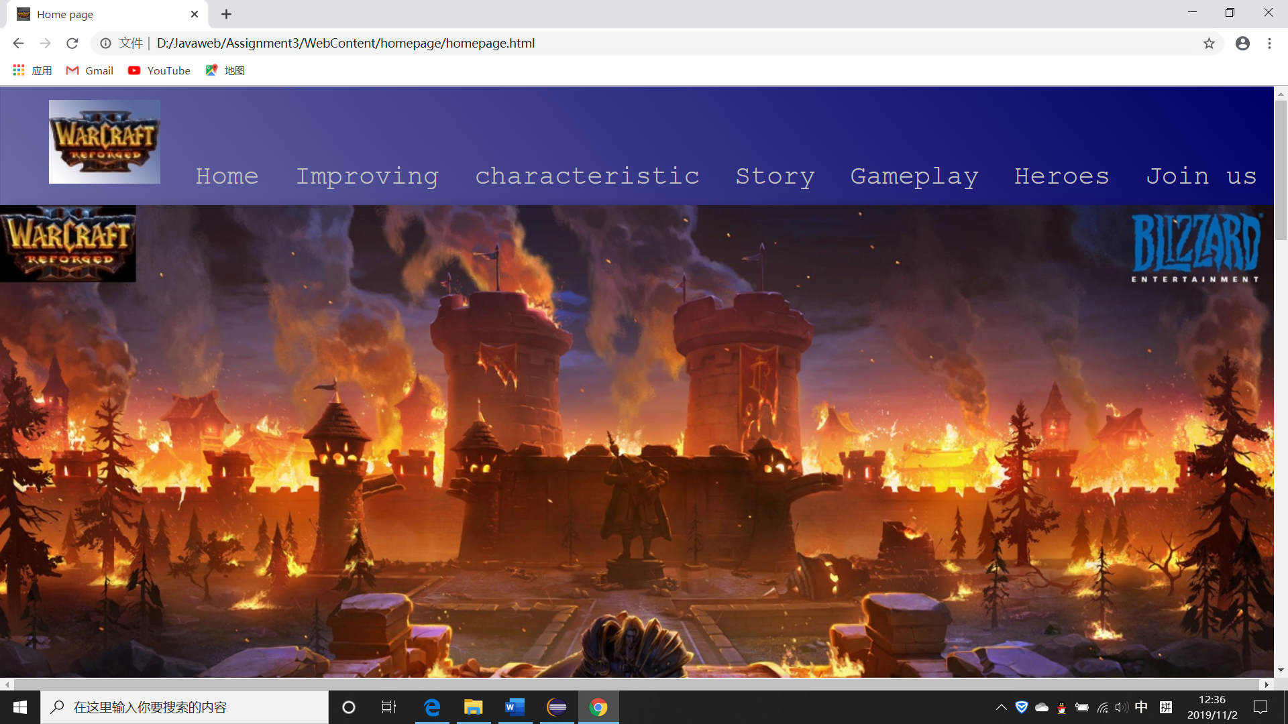

I also put the logo in this position, but it can only be used in Firefox chrome

**Appendix:**

Apart from my information.js uses JavaScript, others don't

JavaScript code:

var *count* = localStorage.length;  
  
function *submited*(){  
 *count*++  
   
 var firstname = document.getElementById("firstname").value;  
 var lastname = document.getElementById("lastname").value;  
 var email = document.getElementById("email").value;  
 var password = document.getElementById("password").value;  
 var phone = document.getElementById("phone").value;  
   
 var timestamp = Date.parse(new Date());  
 var now = new Date(timestamp);  
 var year=now.getFullYear();   
 var month=now.getMonth()+1;   
 var date=now.getDate();   
 var hour=now.getHours();   
 var minute=now.getMinutes();   
 var second=now.getSeconds();  
 *window*.localStorage.setItem("test"+*count*,year+"-"+month+"-"+date+" "+hour+":"+minute+":"+second+" "+"firstname:"+firstname+" "+"lastname:"+lastname+" "+"email:"+email+" "+"password:"+password+" "+"phone:"+phone+" "+"\n")  
  
function *outputinformation*(){  
 var output = document.getElementById("output");  
 output.innerHTML = ""  
 for(var i=0;i<localStorage.length;i++){  
 var key = localStorage.key(i);  
 output.innerHTML += localStorage.getItem(key)+"<br>";  
 }  
   
}  
  
function *clearall*() {  
 localStorage.clear()  
}

**Map:**

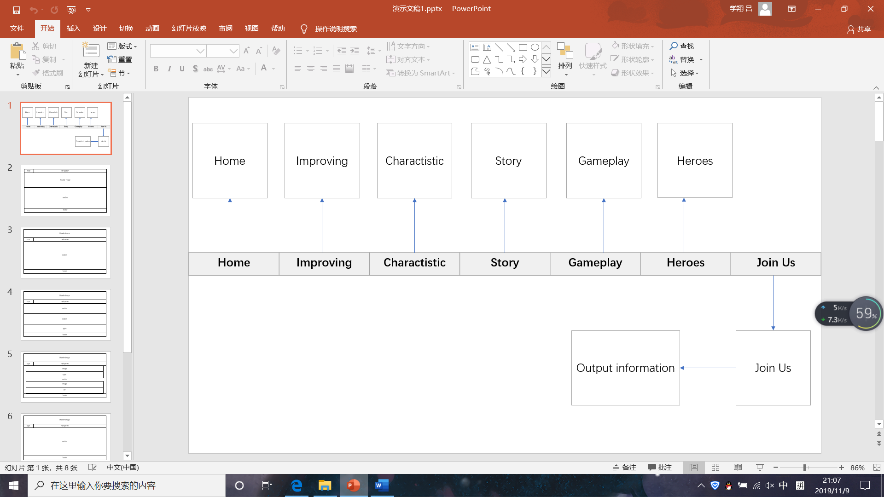

**Homepage**.**html**

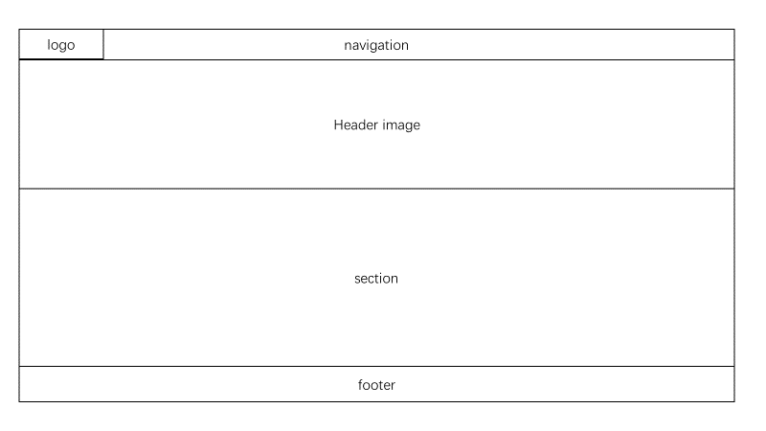

Improving.html

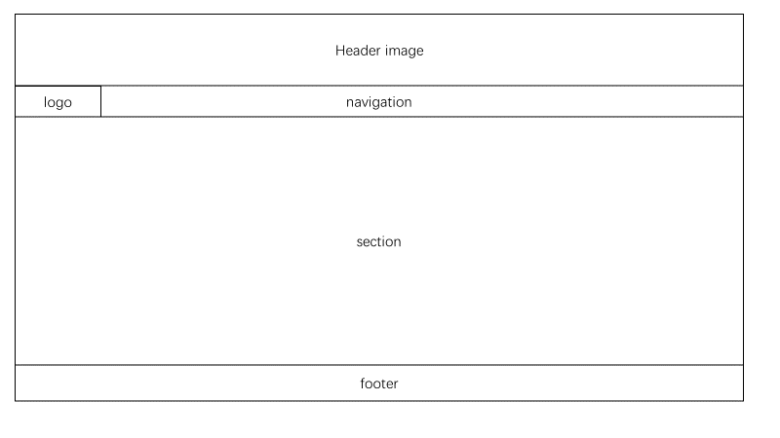

**Charactistic.html**

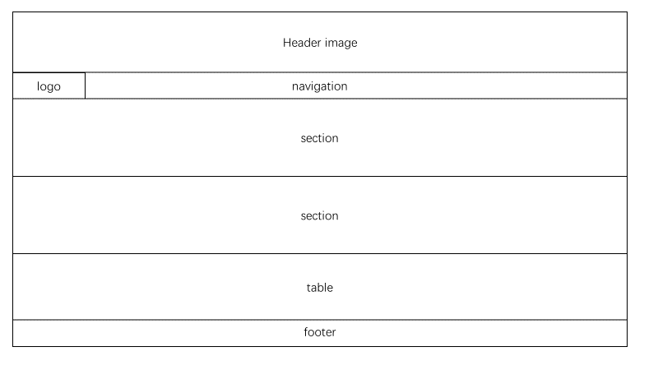

**Story.html**

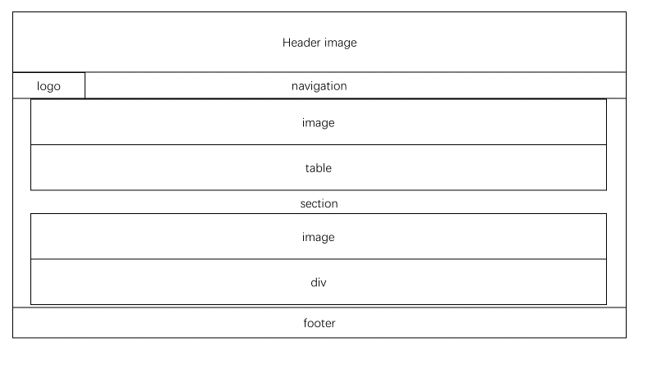

**Gameplay.html**



**Heroes.html**



**Addinformation.html**

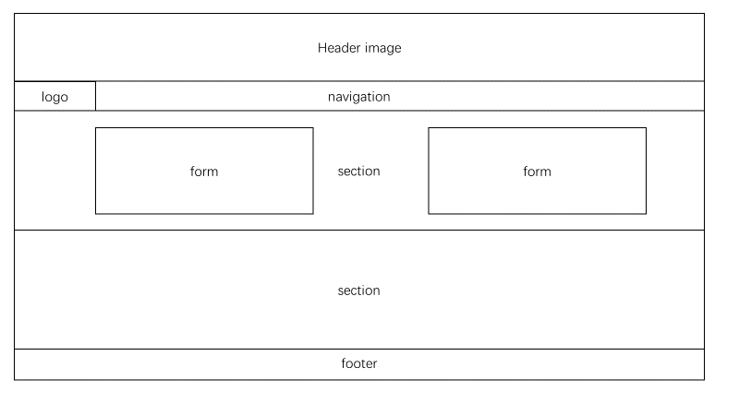

**Table:**

There's an obvious place to use the table tag at the bottom of characteristic.html The other is in story.html

**Animated Image:**

I used a animated image at the bottom of improving.html

**E-mail Link:**

Mailto is used in the footer tag of all web pages

**Outside Link:**

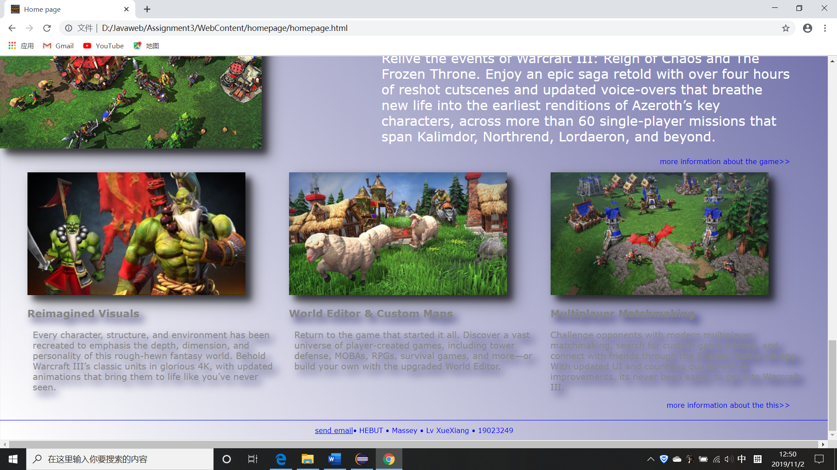  These two hyperlinks link to other external pages in homepage.html 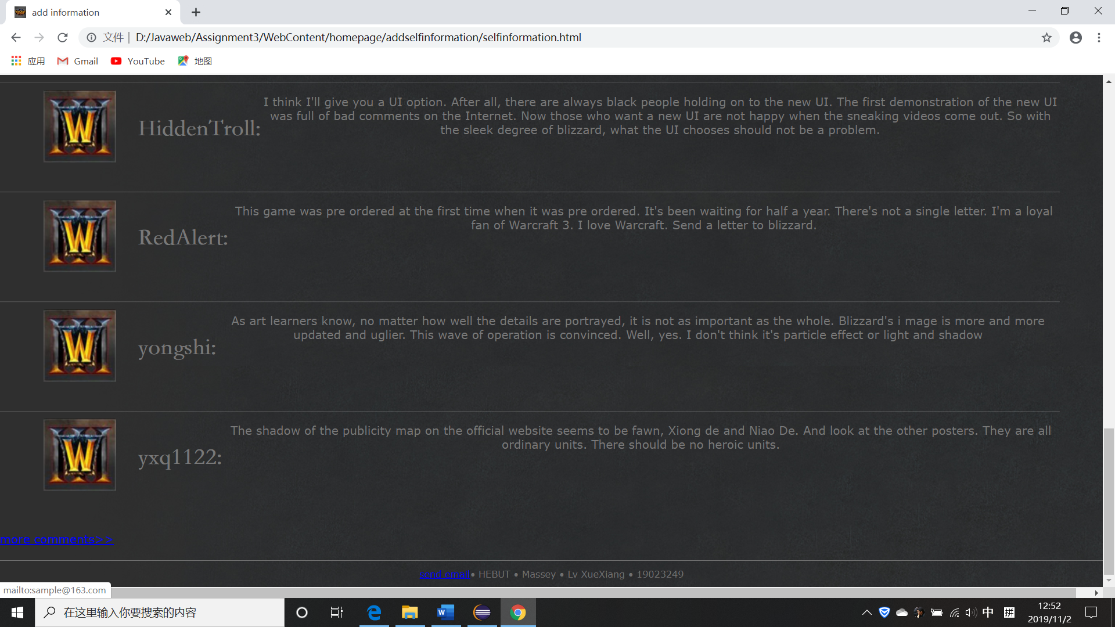 Also in addinformation.html

**Form Coding:**

Form tags are used in addinformation.html to collect information

**Form/Local Storage functionality:**

These functions can be called by form in information.js to collect information and displayed in outputinformation.html. Local storage can only be used in Firefox and chrome

**HTML Validation:**

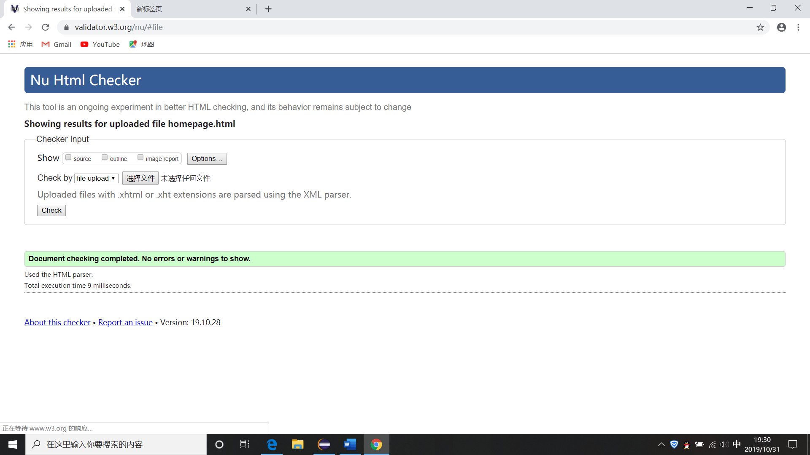

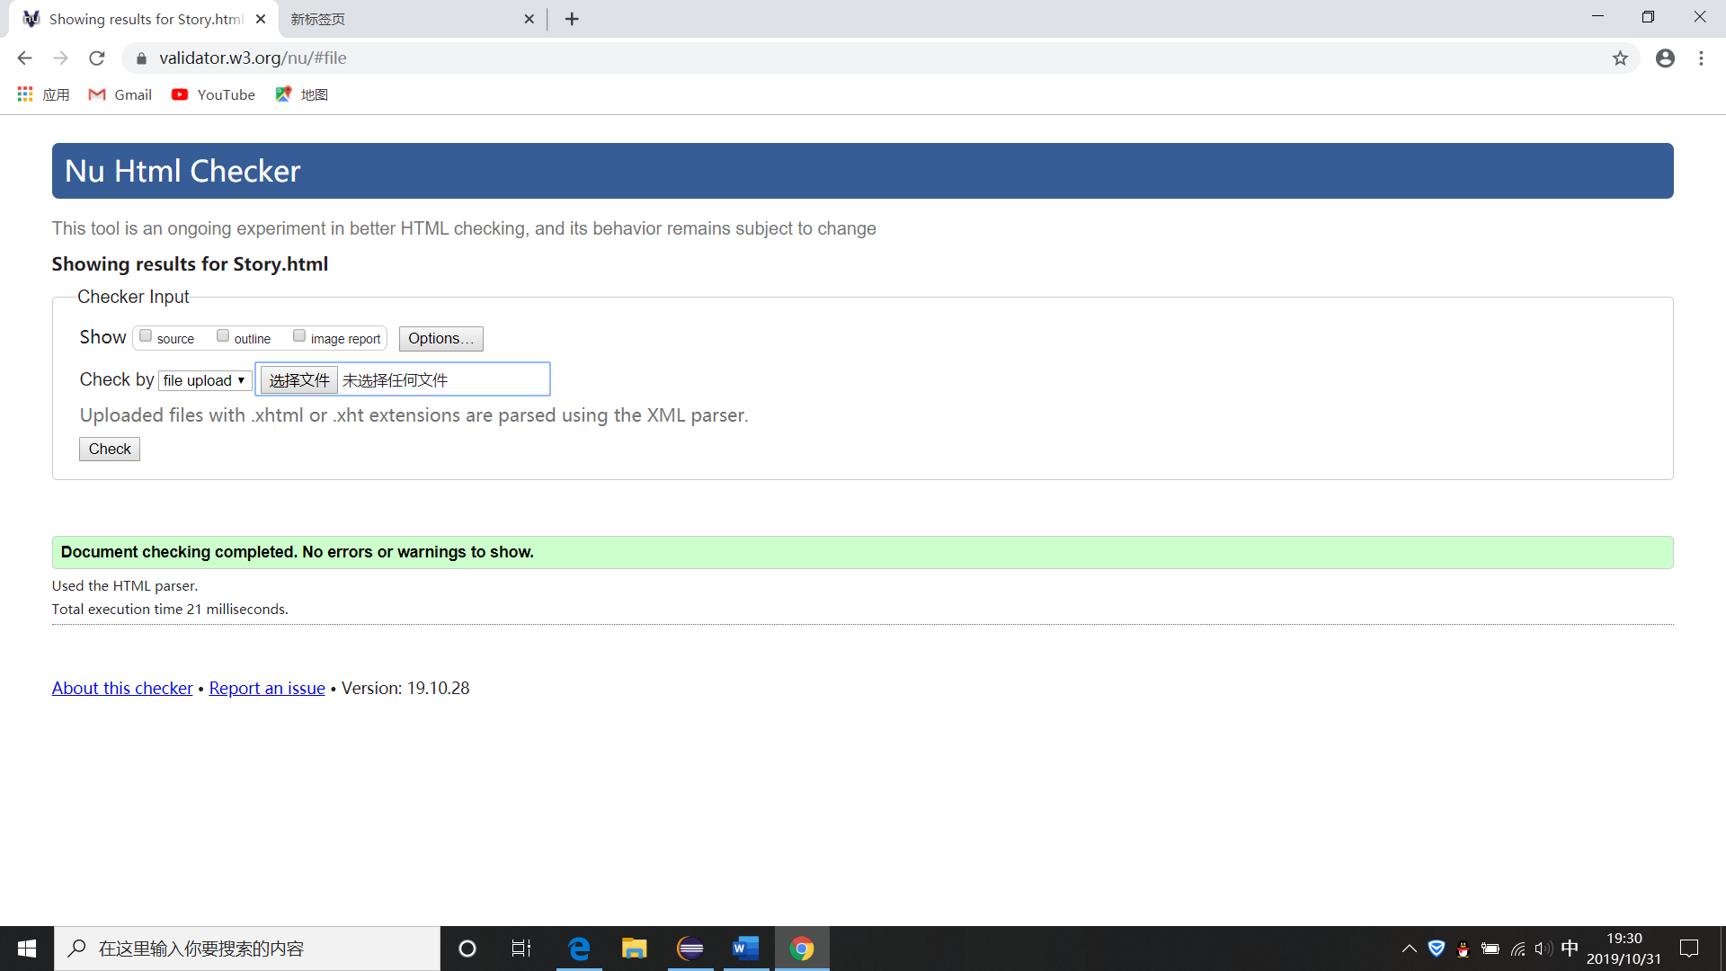

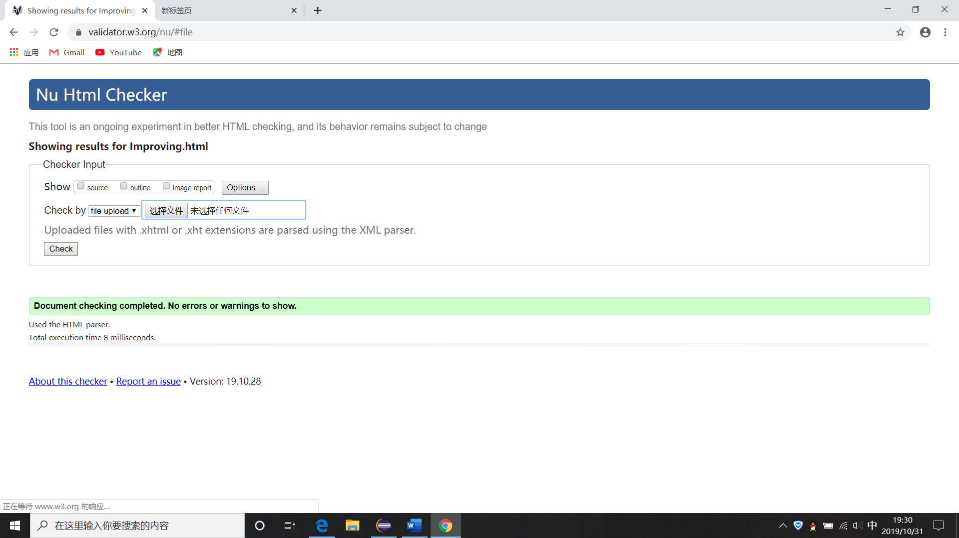

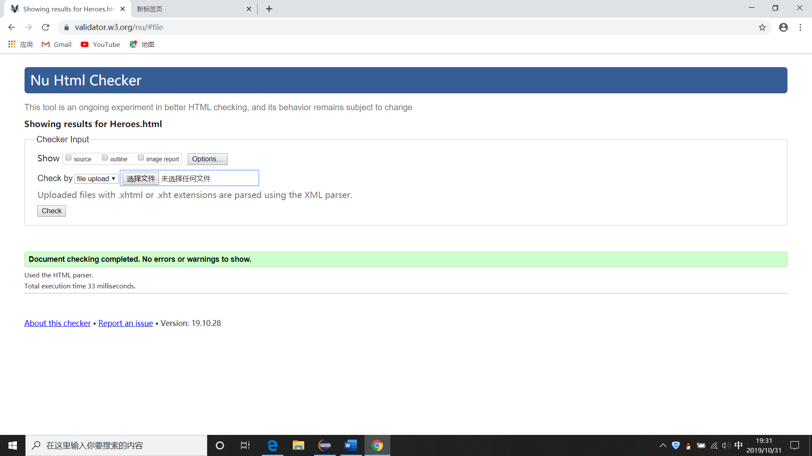

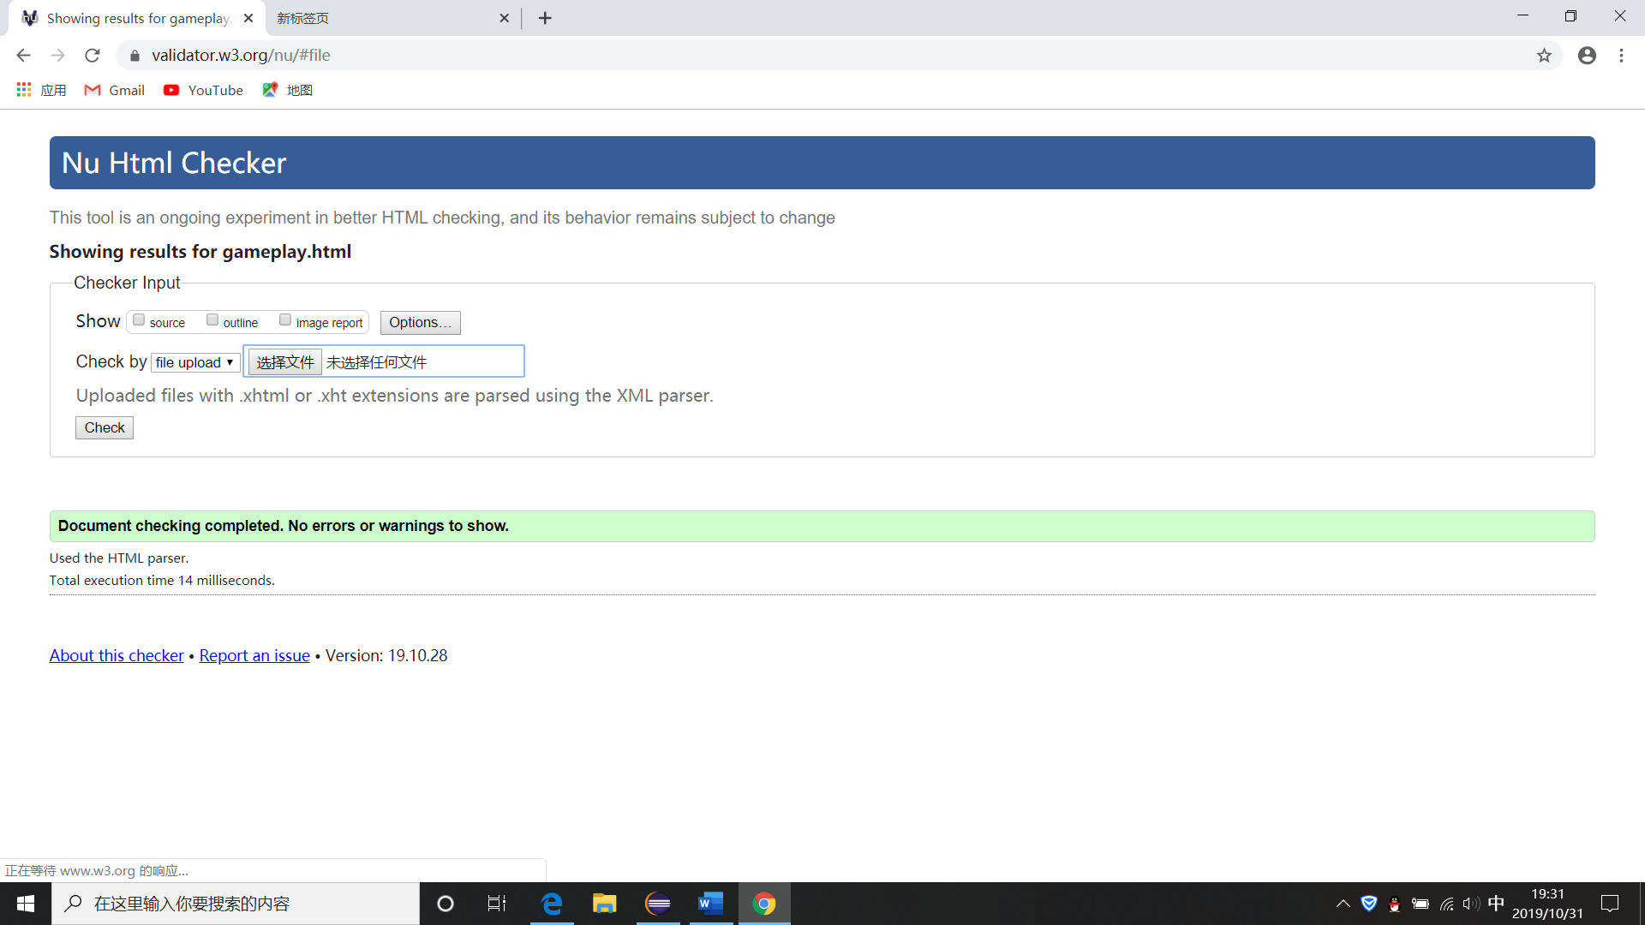

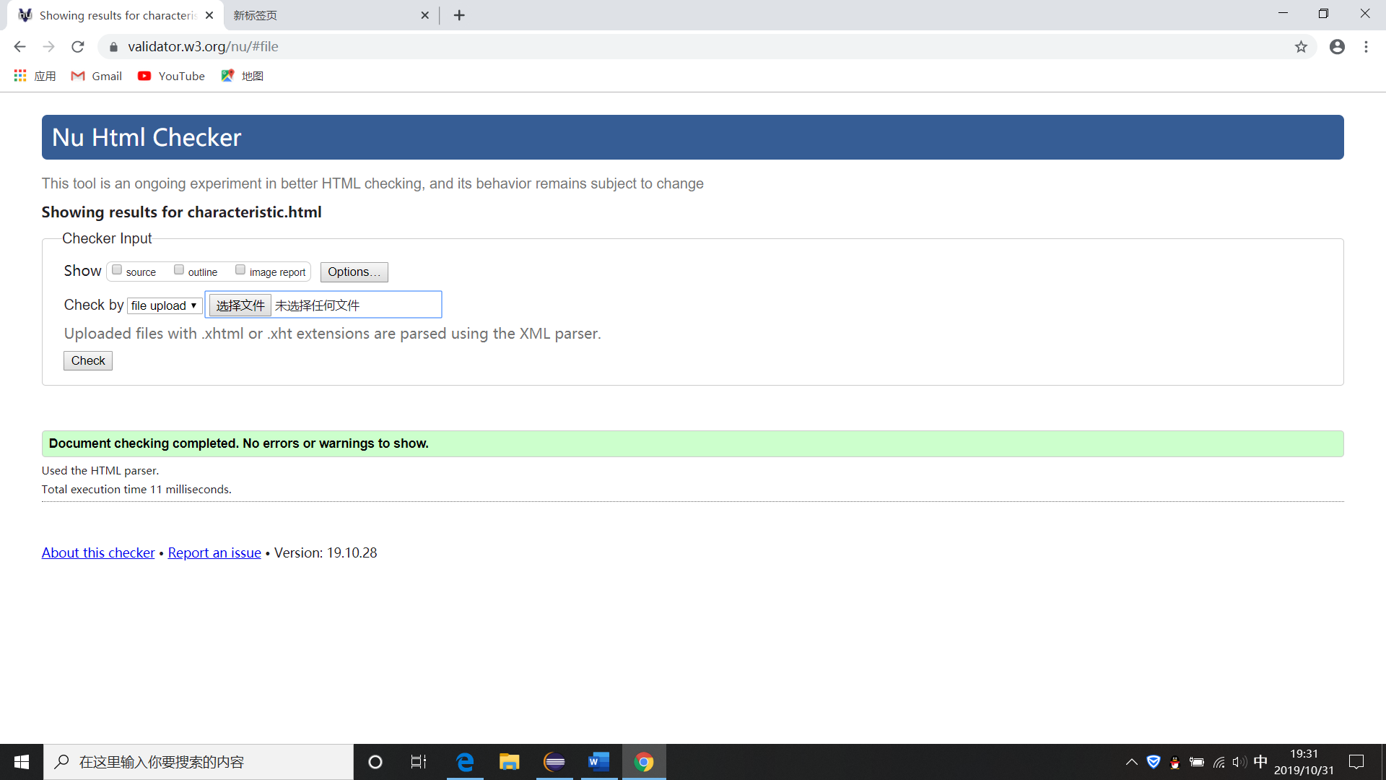

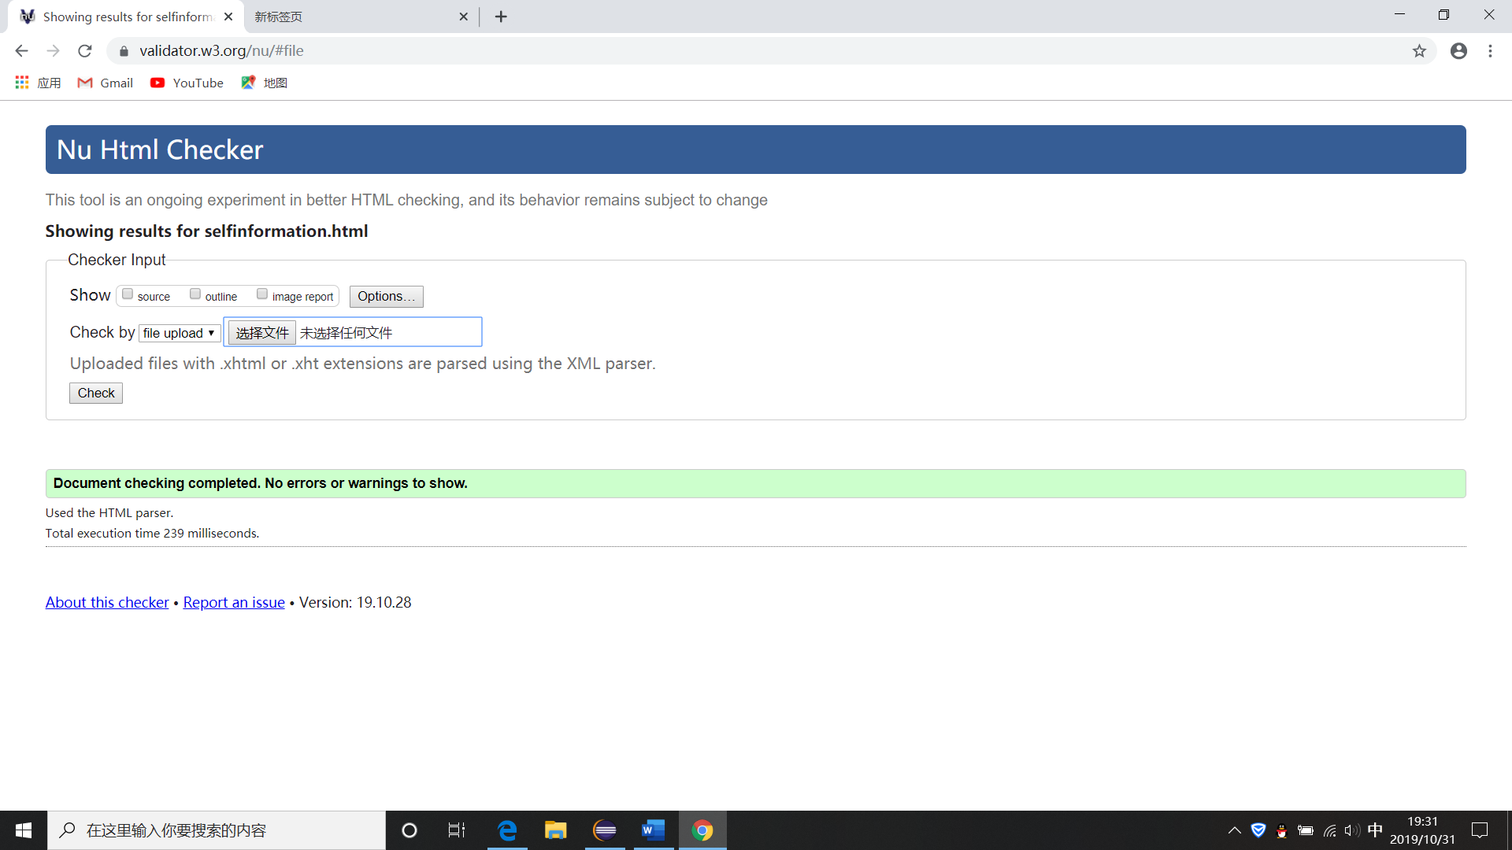

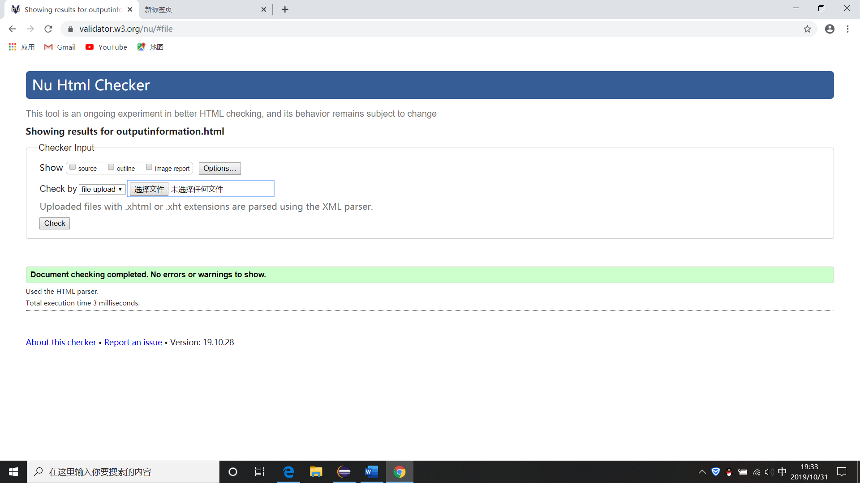

**CSS Validation:**

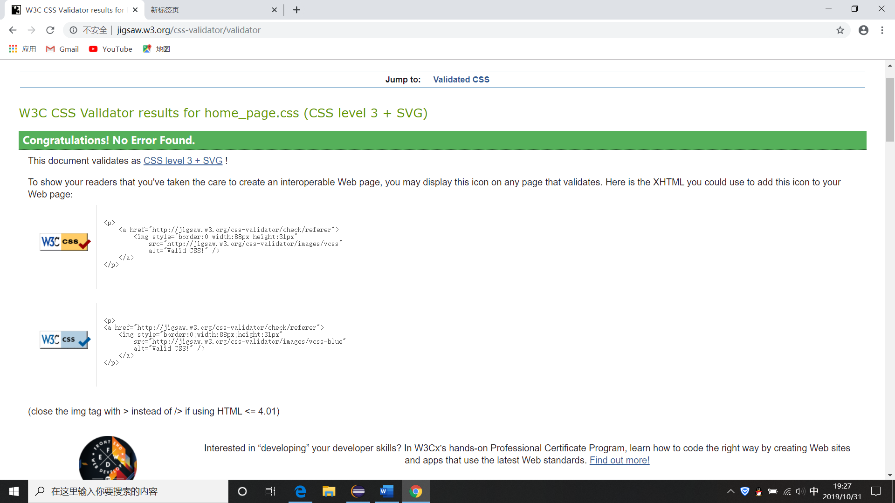

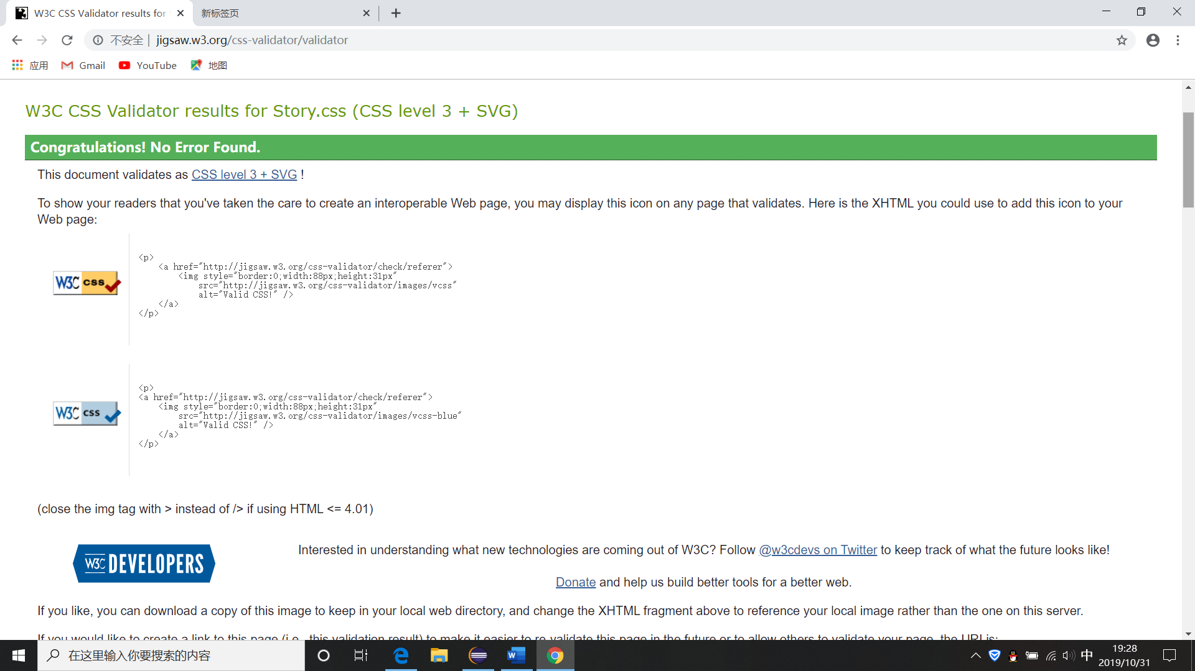

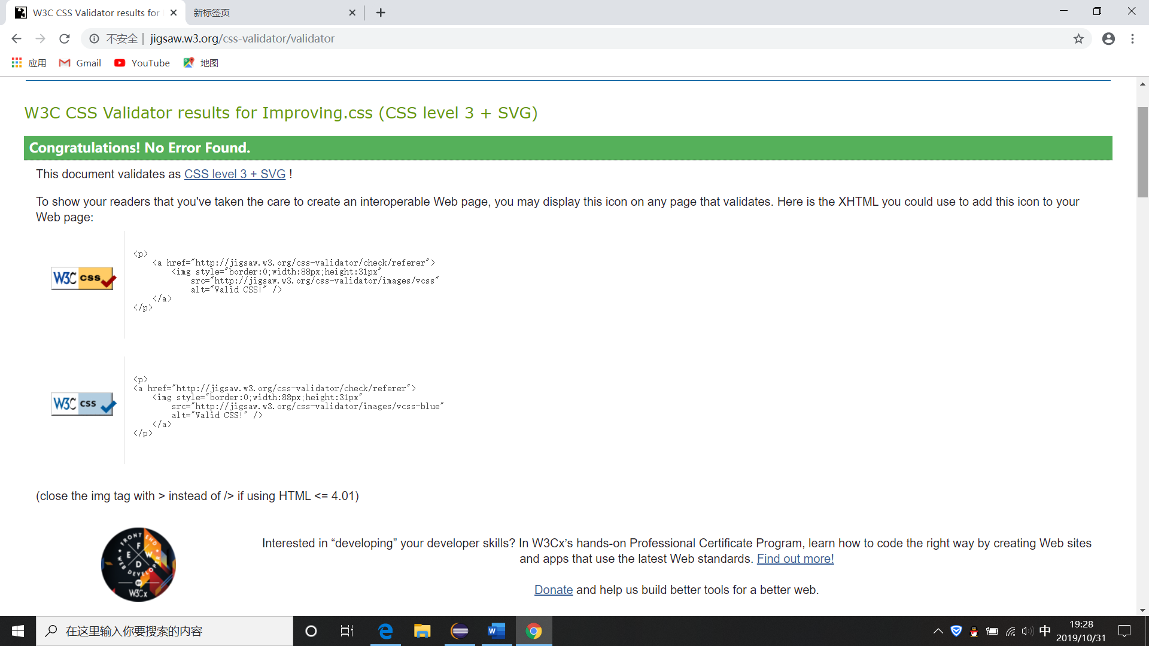

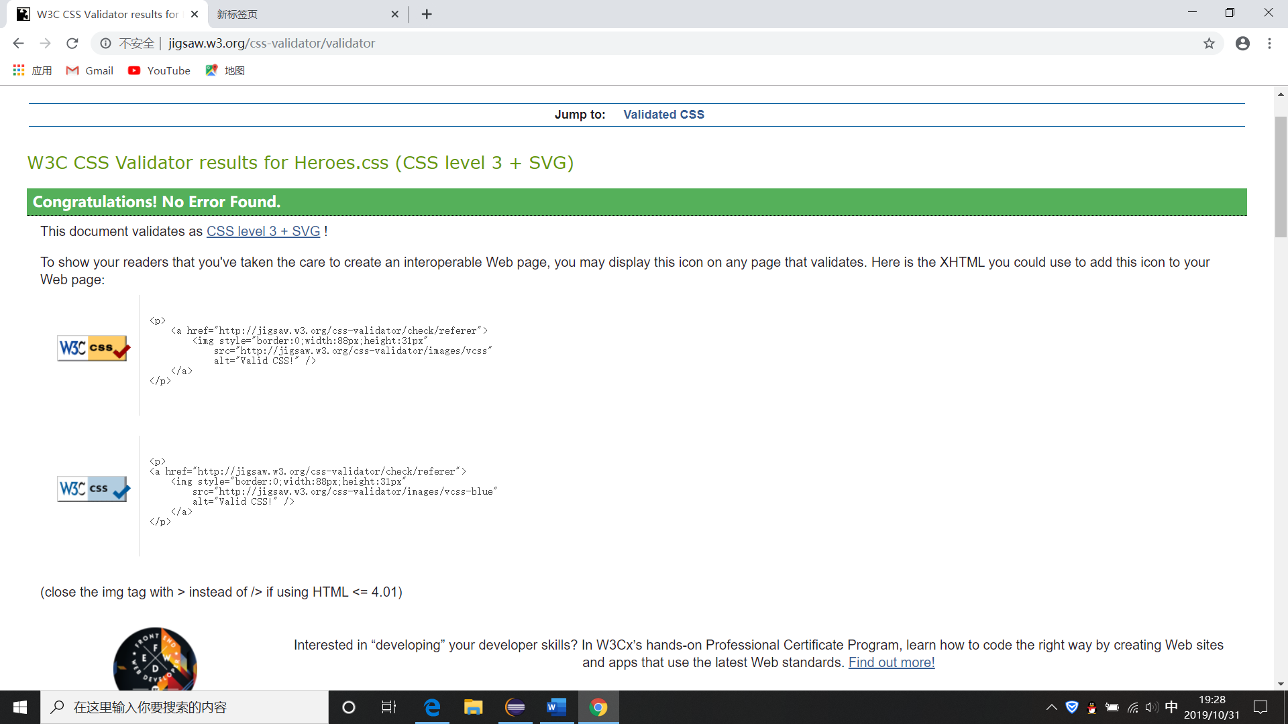

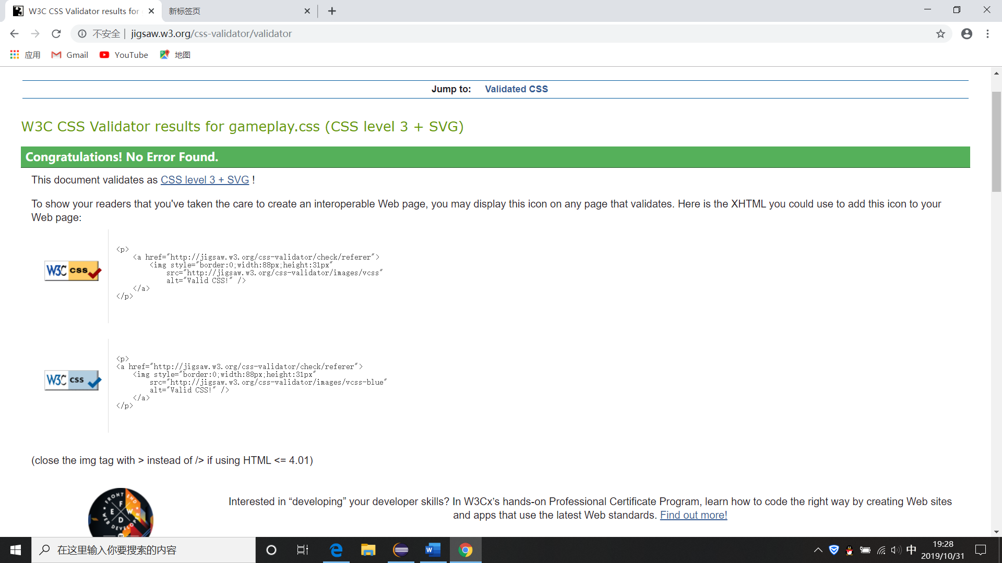

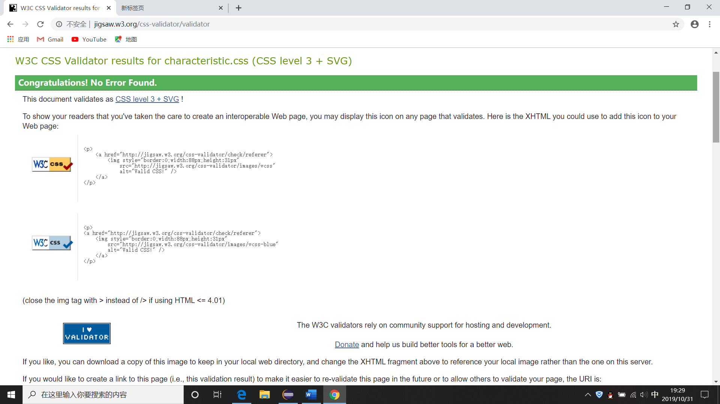

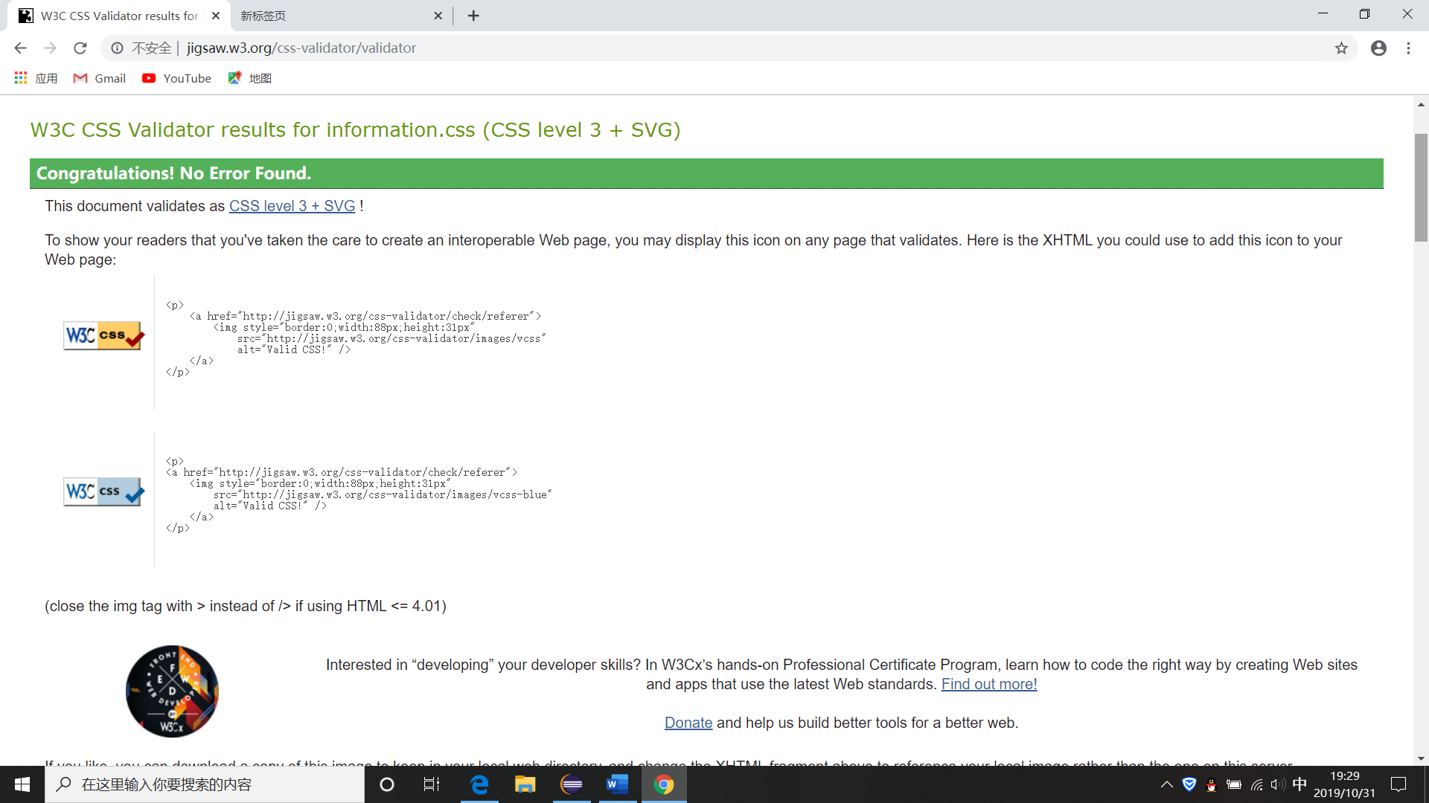**JavaScript - code structure & clarity:**

In the JS file, I wrote three functions and arranged them clearly, one for collecting information, one for output information and one for clearing information. And the information has a time stamp.